# EE 40 Final Hack Proposal

Group 1: Mario Guerrieri and Sai Yerraguntla

## Overview

Replace Launchpad microcontroller by an Intel Galileo development board, with a WiFi card to allow remote control of the robot from a webpage. Modify motor power circuits, adding ultrasonic distance sensors for collision avoidance.

## Hardware Schematic

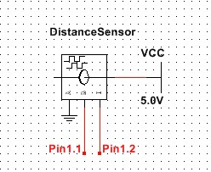

|  |  |
| --- | --- |
| Additional components | |
| Intel Galileo | Free (received from Intel makethon event) |
| SunFounder HC-SR04 Ultrasonic Module (x2) | $9 (from [Amazon](http://www.amazon.com/SunFounder-Ultrasonic-Distance-Mega2560-Duemilanove/dp/B00E0NXTJW/ref=sr_1_1?ie=UTF8&qid=1428871277&sr=8-1&keywords=ultrasonic+sensor)) |
| 66mm robot wheel (x2) | $4 each (from [Amazon](http://www.amazon.com/66mm-Small-Smart-Model-Plastic/dp/B00O2SR4W8/ref=sr_1_9?ie=UTF8&qid=1428873365&sr=8-9&keywords=robot+wheels)) |

## Software Flowchart/Users/marioguerrieri/OneDrive/Schoolwork/EE 40/lab/Final Hack Proposal Flowchart 0.png/Users/marioguerrieri/OneDrive/Schoolwork/EE 40/lab/Final Hack Proposal Flowchart.png